Title: | FCCMPC DOCUMENT CONTROL & PROCEDURE |  |  | Effective Date:
Title: |  |  |  | Original Date: | 24 Sept 2016
Rev No. | Date | Originator | Revision History
1.0 | 24 Sept. 2016 | J. Tibon | - Origination
2.0 | 16 Sept. 2017 | S. Beceril | - To incorporate the conformance of understanding signatories in the creation or revision of policy or procedure
3.0 | 15 Sept 2018 | S. Beceril | - Add details for the control of Documents of External Origin (Reference per para 5.12)  - Added para 6.6 related to the responsibility for routing policy/procedure changes and completing the conformance of understanding
4.0 | 31 Aug 2019 | S. Beceril | - Add details 6.0 creating & revising a policy/procedure.  - Deleted items not necessary in the process  Why Was Change Made?  - Update policy base on the ISO Internal Audit.
5.0 | 19 Oct 2019 | S. Beceril | - Add details 5.3  - Add item 6.7.1  - Add items 7.0 Obsoleting Documents.  Why Was Change Made?  - Update policy base on the GAP Assessment Audit.

- PURPOSE:
  - To establish a standard procedure for the control of documents in FCCMPC.

- SCOPE:
  - Applicable to all documents in FCCMPC only.

- DEFINITION OF TERMS:
  - BOD - Board of Directors
  - Master Copy - is the copy retained by Document Control
- APPLICABLE REFERENCES :
  - Standard Document Contents - Attachment I
  - Standard Document Template - Attachment II
  - Revision Detail -Attachment III

- GENERAL REQUIREMENTS:
  - Document Numbering Scheme.
    - All controlled documents in FCCMPC shall be classified into any of the following :
      - Credit (CR)
      - Financial (FIN)
      - Human Resource (HR)
      - Organizational (ORG)
      - Business Development (BD)
      - Quality Management System (QMS)
    - Each document that shall be originated shall use this numbering scheme.
Example : FC-ORG-XXX
Where FC - refers to Fairchild Cooperative
ORG - refers to the classification of the document
XXX - sequential number assigned to the document starting with 001
  - Version Control
    - Changes made to each document shall have its revisions controlled.
    - Origination shall start with Revision 1.0
    - Each succeeding revision shall use an increment of 1.0.
  - The standard document template and contents are defined in Attachments I and II. The contents of attachments I and II shall define the minimum requirements.
  - All documents shall use Times New Roman font, size 10.
  - The date reflected in the Revision History shall be the BOD Approval date.
  - Effectivity of a policy or procedure shall be within a target period of 10 working days after Board approval.
5.6.1 The actual effectivity date shall be reflected using a dater.
  - Revision Date on the cover page
XXYYZZ
Where : XX | Day
YY | Month
ZZ | Year
Example : 07 Nov 2016

  - Alterations, erasures or highlights are not allowed on the Original copies of controlled approved documents.
  - Erasures done on forms or records shall be done by drawing a single line across the word, phrase or sentence then affixing one’s signature to confirm the change.
    - The use of “White-ink” is not allowed.
  - Original signed documents shall reside in the Master File as a controlled document. Only the Document Control Admin is authorized to remove or create copies of the documents for reference.
5.10.1 Controlled copies of the applicable policies will also be issued to all departments/branch and
have a freshly affixed RED stamp of the CONTROLLED COPY.
5.10.2 These copies shall be acknowledged by the department / branch representative when received.
  - Controlled Copy Identification and Release
    - Controlled hardcopies of documents intended for Master File shall have a freshly affixed RED stamp on the first page of the document that reads:
CONTROLLED COPY
FCCMPC DOCUMENT CONTROL DO NOT REPRODUCE OR REMOVE FROM FILE
    - Copies of documents for personal reference shall have a freshly affixed BLUE “FOR REFERENCE ONLY” stamp on the first page of the document.
UNCONTROLLED COPY
FOR REFERENCE ONLY
FCCMPC DOCUMENT CONTROL
  - Documents of external origin (e.g. ISO 9001 standard, RA 9520) shall be controlled as follows:
    - In establishing the list of external reference standards.
      - Department Heads shall identify all the external reference standards / regulatory & statutory requirements that would impact their process.
      - Department Heads will provide Document Control with the list of the external reference standards, / regulatory & statutory requirements that has been identified, its unique document reference # and a hardcopy of the actual document.
      - Document Control consolidates the list of External Reference standards / regulatory & statutory requirements that would impact the Coop’s operations and maintains a centralized set of hardcopies.
      - Document Control communicates the availability of a new standard(s) to the GM, DGM and all department heads through email so changes in policies or procedures can be initiated, where applicable.
      - Responsible Deparment Head orients those affected by the relevant standard and updates affected policies as applicable.
    - For the review and updating of the list of external reference standards.
      - Department Heads reviews at least on a quarterly basis the list of external reference standards, regulatory & statutory requirements (that would impact their process & the coop's operations) which are not version controlled and check for any updated memorandums or circulars that would supersede earlier issuances.
      - Document Control reviews at least on a quarterly basis the list of external reference standards (which are version controlled) and checks for any updated version.
      - Department Heads provides Document Control with a list of the UPDATED external reference standards, regulatory & statutory requirements, its unique document ref # and a hardcopy of the actual document.
      - Document Control updates the list of external reference standards, regulatory & statutory requirements, maintains copies of the documents either in soft or hard copies as applicable.
      - Document Control communicates the availability of the updated standard(s) / regulatory & statutory requirement memos & circulars to the GM, DGM and all department heads through email so changes in policies or procedures can be initiated, where applicable.
      - Responsible Dept Head orients those affected by the relevant external standard / regulation and updates applicable policy / procedure as needed.
  - Control of Brochures / Leaflets on the services provided by FCCMPC shall reflect the date when these have been released. Date release shall capture the Month and Year it was released.
- CREATING OR REVISING A POLICY / PROCEDURE
  - New policies or procedures shall be assigned a document number by the Document Control Admin.
  - The BOD or its designate are authorized to create or revise a policy / procedure.
  - Revisions made to a policy or procedure shall be approved by the BOD.
  - Changes to a policy or procedure shall be made readily visible to approvers using the Revision Details page, (Attachment – III)
  - Table of Contents (TOC), both for the Master List and individual binders, shall be updated if there is new policy.
    - Master List TOC Information : Policy Title, Document No., Approval Date, Revision No. & Distribution List
    - Individual Binder TOC Information : Policy Title, Document No., Approval Date, Revision No.
    - Manually writtten changes are allowed only for revision changes or addition of distribution locations.
  - The conformance of understanding shall be signed by no less of the following:
    - General Manager or Chief Executive Officer
    - Deputy General Manager or Deputy Chief Executive Officer
    - Supervisors/Section or Department Heads
    - Concerned Employee of the specific policy
  - The initiator of the change shall be responsible to facilitate the complete approval of the policy / procedure and acknowledgment of the conformance of understanding. Once completed, hardcopy and softcopy of the policy shall be forwarded to document control within 10 working days.
    - In case of the long absence of the employee, the originator will orient the returning employee of which policies were revised/originated that would affect his/her function. Then to confirm the completion, the employee will signed the conformance of understanding and note the actual date.
- OBSOLETING DOCUMENTS:
  - When a policy / procedure is no longer applicable, this can be made obsolete by doing the following:
    - Complete the cover page and reflect the “Obsolete” in the revision history column with the reason why this need to be made obsolete.
    - Route the cover page only with the page for the Board Approval.
    - Once approval is complete, remove the Master copy and retrieve all the other controlled copies based on the distribution list.
    - Stamp the Master Copy “OBSOLETE” and destroy the rest of the retrieved controlled copies. However, softcopy of the obsolete document should be retained and store on a separate file.
- RESPONSIBILITY:
  - Document Control Administrator
    - Ensure that this procedure is enforced.
    - Update all the Master file of all the applicable approved policies or procedures.
    - Remove all obsolete controlled documents from the master file and transferred to the Archive.
    - Review this procedure and recommend revision, if deemed necessary.
  - Originator
    - The originator shall review the entire procedure when changes are made to ensure that everything is aligned.
    - Ensure continuity of the revised policy with that which was made obsolete.
    - To define those who will be included in the Conformance of Understanding.
    - Ensure that all affected personnel understand the changes of the policy or procedure.

Attachment I

Standard Document Content

- TITLE:
Set into TITLE space a brief but totally descriptive phrase for the subject of the policy.

- PURPOSE:
A detailed, accurate and complete statement of the results expected and intent of the policy.

- SCOPE:
A statement defining the extent to which the documents affect , departments, area ,and procedures.

- APPLICABLE DOCUMENTS : (when applicable)

A complete list of all the policy necessary to implement the instruction, either by use or reference.

- PROCEDURE:
A complete step by step description of exactly how to implement the instruction and achieve the
proper result.

- RESPONSIBILITY :

Defines the respective responsibility of the people concerned to ensure proper implementation of the
instruction in the policy as well as the responsibility to update the policy.

Attachment II

Standard Cover Page Template

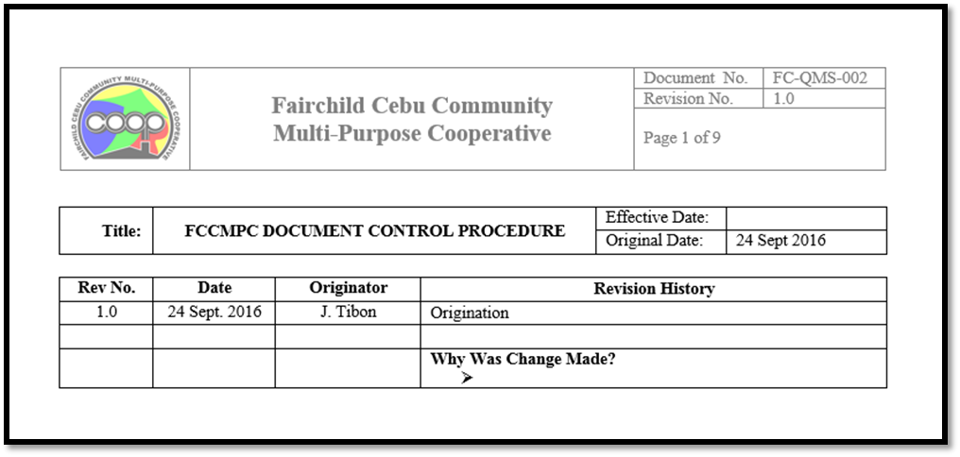

Attachment III

Revision Details
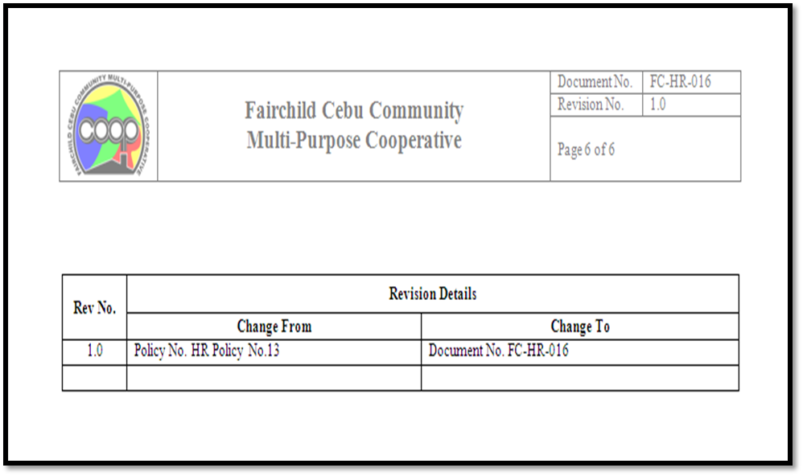

BOARD APPROVAL

MARIA CRISTINA B. ESTACIO
Chairman – BOD

JERRY I. DULCE  (Vice Chairman – BOD) |  |  | SIXTO L. WAHING  (Member – BOD)
GODOFREDO I. GEQUILLO  (Member – BOD) |  |  | NOEL P. NUÑEZ  (Member – BOD)
JEMA C. TIBON  (Member – BOD)  _______________________________________  DARYL S. GO  (Member – BOD |  |  | JOSEFINA I. RICAFRANCA  (Member – BOD)  __________________________________________  PORFERIO S. MONTESCLAROS JR.  (Member – BOD)
MARY ANNE G. MACARAEG  (Secretary) |  |  | ALENA TERESA L. SEPULVEDA  (Treasurer)

CONFORMANCE OF UNDERSTANDING

NAME SIGNATURE/DATE

REYNALDO A. GANDIONCO ____________________________

RUDOLPH C. MONTAYRE ____________________________

SHEILA MARIE B. BECERIL ____________________________

LUSMINDA L. BUAGAS ____________________________

WHIENDELYN L. ENERO ____________________________

NENITA M. RICAFORT ____________________________

ANNALIN E. SORELA ____________________________

MARY SALVIE S. ABASTAS ____________________________

REGINA MARIE SUICO ____________________________
JOECRIS Z. ESPAÑOL ____________________________
TEOFREDO C. LLIDO JR. ____________________________
____________________________ ____________________________

____________________________ ____________________________
____________________________ ____________________________

Rev No. | Revision Details
Rev No. | Change From | Change To
5.0 | Added:  5.0 GENERAL REQUIREMENTS:  5.3 The standard document template and contents are defined in Attachments I and II.  6.0 CREATING OR REVISING A POLICY /  PROCEDURE  Added: 6.7.1  7.0 OBSOLETING DOCUMENTS:  7.1 When a practice is no longer applicable and has been decided to be eliminated, the policy defining the procedure shall be made obsolete.  7.1.1 Master copies are stamped  “OBSOLETE” and archived. | 3.0 DEFINITION OF TERMS:  3.2 Master Copy – is the copy retained by  Document Control  5.3 The standard document template and contents are defined in Attachments I and II. The contents of attachments I and II shall define the minimum requirements.  6.7.1 In case of the long absence of the employee, the the originator will orient the returning employee of which policies revised/originated that would affect his/her function. Then to confirm the completion, the employee will signed the conformance of understanding and note the actual date.  7.1 When a policy / procedure is no longer applicable, this can be made obsolete by doing the following:  - Complete the cover page and reflect the “Obsolete” in the revision history column with the reason why this need to be made obsolete.  - Route the cover page only with the page for the Board Approval.  - Once approval is complete, remove the Master copy and retrieve all the other controlled copies based on the distribution list.  - Stamp the Master Copy “OBSOLETE” and destroy the rest of the retrieved controlled copies. However,softcopy of the obsolete document shoud be retained and store on a separate file.

